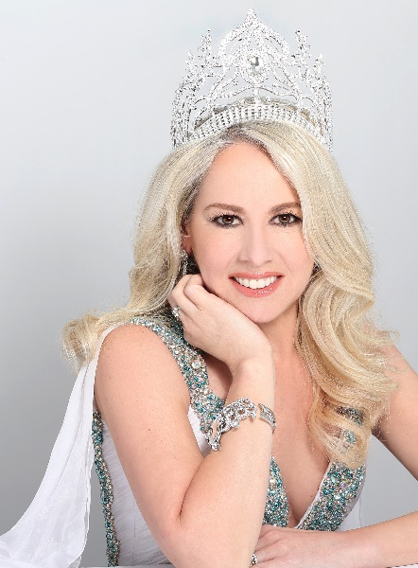

Susan Bawlick Pagan
Mrs. Hemisphere
Pageant Pros, LLC
Much of my upbringing was under, what I consider extreme poverty conditions (at least for living in the USA it was). The fact was: our house was literally falling apart around us! Most winters we went without heat, our plumbing and water often failed. During my senior year of high school our house had become unsafe to live in, and we were forced to separate as a family. For over a decade I had no place to call home while I slept on friends’ and boyfriends’ couches. Even though I was living like a gypsy with no real home, there was a deep fire within me to turn my challenging experiences into tools for power. I believe this is what led me to finally getting my Master’s Degree in Healthcare Administration, because I have an innate desire to help others. I know that since I triumphantly emerge from this trial; that it is not only my responsibility but my privilege to help others who struggle in similar circumstances and teach them tools to empower themselves.
My life was forever changed during a mission trip to Jordan while I visited with refugees to hear their stories. I was touched so deeply by their continued hospitality toward us even during their time of complete loss and despair. I shared some of my story with them and hoped that even one person would be encouraged to hear how I overcame a living environment similar to what they were experiencing. Since that time, I have had a desire to seek out, reach out, and to serve those who are homeless, those who are in compromised living conditions, and those who are displaced. I have served on a several local programs which provide help to the less fortunate by way of supplying groceries and housing needs. Nationally and Internationally my husband and I travel a great deal, spending at least half of our vacation time devoted to mission work where we continue to encounter opportunities to serve the less fortunate all around the world. I am the National/International Spokesperson for Off The Streets: an organization that offers security deposits, start-up home goods and furniture, and a supply of groceries to literally take people/families off the streets and place them into homes of their own. As Mrs. Hemisphere, I am an Ambassador for The Pledge Against Domestic Violence: an organization started by Director and Owner of Hemisphere Pageants, Pageant Pros, LLC & Mrs. Universe 2014-- Sabrina Pinion which raises awareness for, but it also enlists every man, woman, and child to do their part in the fight against domestic violence.
As a pageant titleholder, I have had wonderful opportunities to tell my story to help change other people’s stories. I became involved with the Connecticut Coalition to End Homelessness and ran road races to help raise money for the “be homeful” campaign. Being a pageant titleholder opens many doors for speaking engagements and guest appearances. My story was published in “The Hamlet Hub” in Ridgefield, CT and the national “Platform” magazine, and I appeared on the local show “Hangin’ with Dee”.
As Mrs. Hemisphere 2016, I will travel to China and compete for the title of Mrs. Universe. Mrs. Universe is a forum where I will be given the privilege to present my platform of homelessness and how it relates to domestic violence in our country-- to over 70 competing women, several judges, the owners of the pageant, and any general public in attendance. The Mrs. Universe Forum is a unique and amazing opportunity, and I am humbled and honored to be invited to take part in it. Being a part of this forum is only the beginning of my year’s journey as Mrs. Hemisphere, and I am thrilled to become part of this prestigious pageant family forevermore.
When I am not trying to save the world, I am traveling it with the greatest man in the world, my husband Ivan; or I am running in a marathon. I am a published author of children’s and adult books which teach lessons on building self-esteem and dealing with emotions. I have launched an online business (PagansNoMore, LLC which sells my books, original t-shirt/mug designs, and virtual marathons. All and any money the business makes will be donated to various organizations serving the basic needs of individuals and/or families in need.
susanbawlickpagan.com

